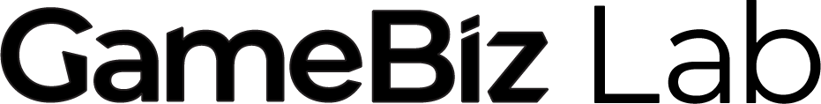


Applicant Eligibility and Application Form

GameBiz Lab is bringing education and consulting around the business side of video games to Manitoba’s video game community.
For high-potential indie video game studio owners: Apply to be part of the 2025-26 GameBiz Lab cohort. Benefits include:
- Priority access to consultations with industry experts
- The ability to book NMM’s space, subject to availability
- Exclusive cohort meetup opportunities*
- Participation in an end-of-program showcase event
- Additional benefits as confirmed
Eligibility:
- Be a resident of Manitoba
- Leading a video game studio in Manitoba
- Be willing and available to participate in most monthly events and gatherings. Virtual options can be arranged for approved participants located outside of Winnipeg, Manitoba.

This program aims to support studios that have done at least one of the following:
- Launched at least one full game;
- Secured funding from the Canada Media Fund (CMF);
- Partnered with a publisher.
If you do not meet one of these criteria, you are encouraged to contact Corinne to explore eligibility.

Applications will be assessed based on potential for success (such as past games success, current maturity of the studio, etc.). Additional consideration will be given to participants from equity-seeking communities.

Please submit this form to corinne@newmediamanitoba.com to apply for the GameBiz Lab Cohort Program running from September 2025 – March 2026.

If you do not receive an acknowledgment of receipt within 2 business days, please contact Corinne to confirm. All applications must be submitted by Sunday, August 17th. Approved cohort participants are expected to be notified by the end of August.

*New Media Manitoba will organize opportunities to meet in our training space during times designated for the cohort to be able to mingle, ask questions, and share insights.

General Questions
Full Name
Do you lead an indie video game studio in Manitoba? Yes/No
Studio Name
(Your studio does not have to be incorporated.)
Current Project Name
Community of residence (This program is only available for residents of Manitoba.)

Project Questions

- Please share which of the following you have previously achieved:
- Launched at least one full game;
- Secured funding from the Canada Media Fund (CMF);
- Partnered with a publisher.
- None of the above
Please describe further below. (1 paragraph)

- Please briefly describe your experience with video game development and your work background. (1-3 paragraphs)

- Briefly describe your studio, when it was established, and your studio’s vision. (1-3 paragraphs)

- Describe your current team (including any contractors). (1-3 paragraphs)

- Briefly describe your current game project. (1-3 paragraphs)

- Please share your current progress and the project plan & roadmap. (up to 5 paragraphs)

- Please provide your competitive analysis and marketing plan. (up to 5 paragraphs)

- Please provide your project budget. (Can be an attached spreadsheet or a categorized list below)

- How do you see New Media Manitoba’s support in helping you succeed with your project?

- Do you anticipate any barriers that would affect your ability to attend monthly evening sessions with experts, monthly one-on-one consultations during work hours, and meetups with other cohort participants every two months?

- Please attach any further information you feel is relevant to your application.

Demographics and Self-Declaration Questions

I use the following pronoun(s) (You may choose more than one)
_ She/Her
_ He/Him
_ They/Them
_ Any pronouns
_ Other, please specify __________________
_ I prefer not to answer

2. I am a Canadian citizen or permanent resident
_Yes
_ No

3. I am a resident of Manitoba
_Yes
_ No

4. NMM is committed to serving individuals from equity-seeking groups with this program.
Please select any of the following equity-seeking communities that you belong to:
_ Indigenous peoples to Canada
_ Racialized Communities / Visible Minority
_ Women or gender-diverse individuals
_ 2SLGBTQ+
_ Disabled persons or persons with disabilities
_ Official Language Minority Communities (Francophone in Manitoba)
_ None of the above
_ I prefer not to say

Please submit your completed application to corinne@newmediamanitoba.com by Sunday, August 17th, 2025.

